**PERSONAL BLOG ON IBM CLOUD STATIC WEB APPS**

**Phase 5 Submission Document**

|  |  |
| --- | --- |
| NAME | KRISHNARAJ K |
| TEAM ID | 8935 |
| TEAM NAME | Proj_207157_Team_2 |
| PROJECT NAME | 8301-Personal Blog on IBM Cloud Static Web Apps |
| SUBMISSION DATE | 01-11-2023 |

**Project** **Overview**:

The travel blog project aims to create an engaging and easy-to-manage travel blog using the static site generators Jekyll or Hugo. The primary objectives include simplifying the content management process, enhancing the visual appeal of the blog, and ensuring a seamless user experience for readers. This project embodies a user-centered design approach to meet the needs and expectations of both the author and the audience.

**Design Thinking Process:**

**1. Empathize:** The project started by understanding the challenges and aspirations of travel bloggers. This involved identifying pain points in content management, design aesthetics, and user experience.

**2. Define:** The project objectives and scope were defined, emphasizing the need for an intuitive content management system, customizable design, and easy deployment options.

**3. Ideate:** The selection of static site generators, Jekyll or Hugo, was an outcome of brainstorming, considering their strengths in content management and design flexibility.

**4. Prototype:** Prototypes and mockups were created to visualize the blog's structure and design, ensuring a user-friendly layout and visual appeal.

**5. Test:** Testing was performed iteratively, addressing usability and design concerns, refining the project's direction.

**Development Phases:**

**1. Setting Up the Development Environment:** Installation of Ruby for Jekyll or Go for Hugo was carried out, creating the necessary programming environment.

**2. Creating the Project:** A new project was initiated with the chosen static site generator. The project's structure and initial configuration were established.

**3. Organizing Content:** Content organization involved writing blog posts in Markdown format, adding YAML or TOML front matter for metadata, and structuring the content for easy management.

**4. Customizing the Design:** The blog's design was customized using themes, templates, and plugins to create a unique and engaging visual experience.

**5. Building and Deploying the Blog:** The blog was built for previewing, tested, and finally deployed to a hosting platform to make it accessible to the public.

**Website Structure:**

The website is organized into sections, including a homepage, blog posts, about section, and a contact page. A clear navigation menu is provided for users to explore the content easily.

**Content Creation:**

Blog content is created in Markdown format, which simplifies writing and formatting. YAML or TOML front matter is used to add metadata, such as post titles, dates, and layouts.

**Technical Implementation:**

**Static Site Generator:** Jekyll or Hugo is used, enabling easy content management and flexible design customization.

**Deployment:** The blog is deployed using hosting services like GitHub Pages or Netlify for simplicity and accessibility.

**Design Customization:** Themes, templates, and plugins are implemented to create a visually appealing and unique blog.

**Technical stack:-**

HTML

CSS

Python – Flask

**Software used:-**

VS Code

**Website pages :-**

Home page

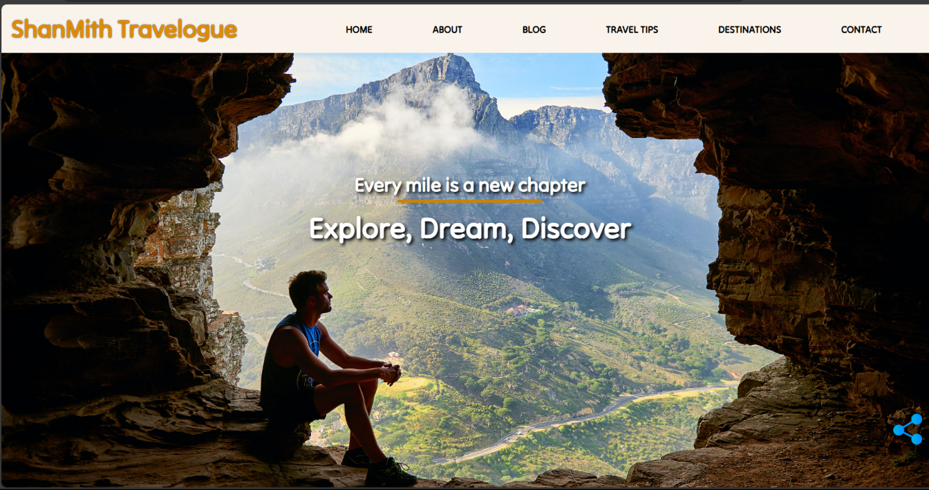Discover captivating destinations, read insightful travel tips, and embark on adventures from the comfort of your screen.

About page

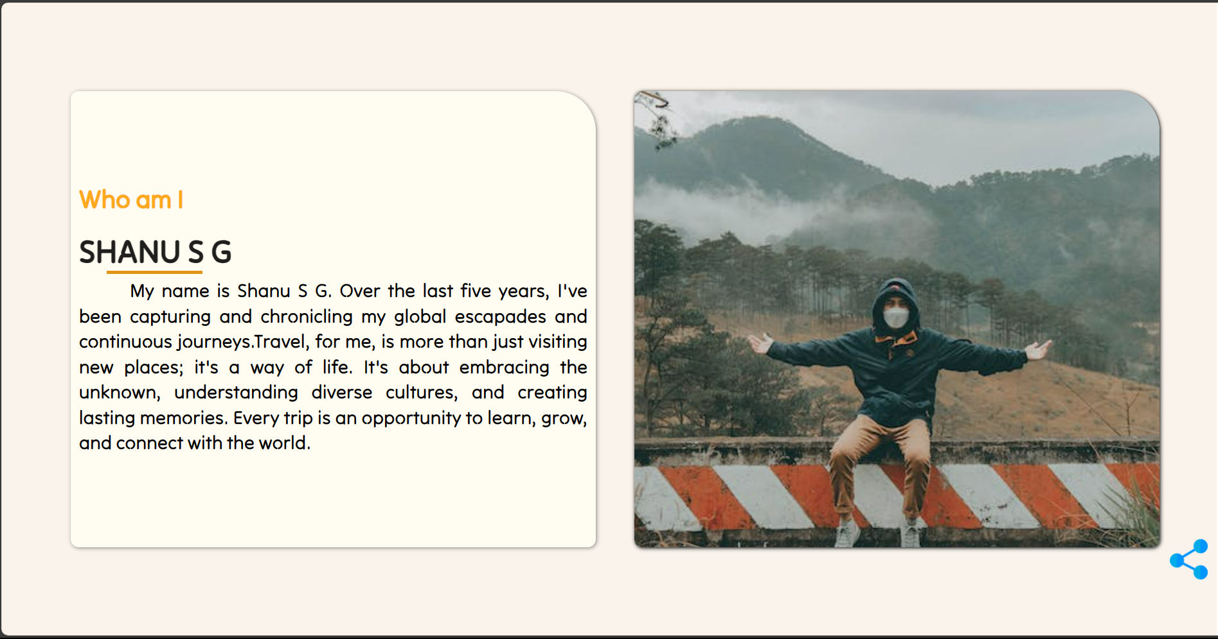We are a passionate group of explorers sharing our love for travel with the world. Learn about our journey, mission, and the individuals who bring our travel stories to life.

Blog Page

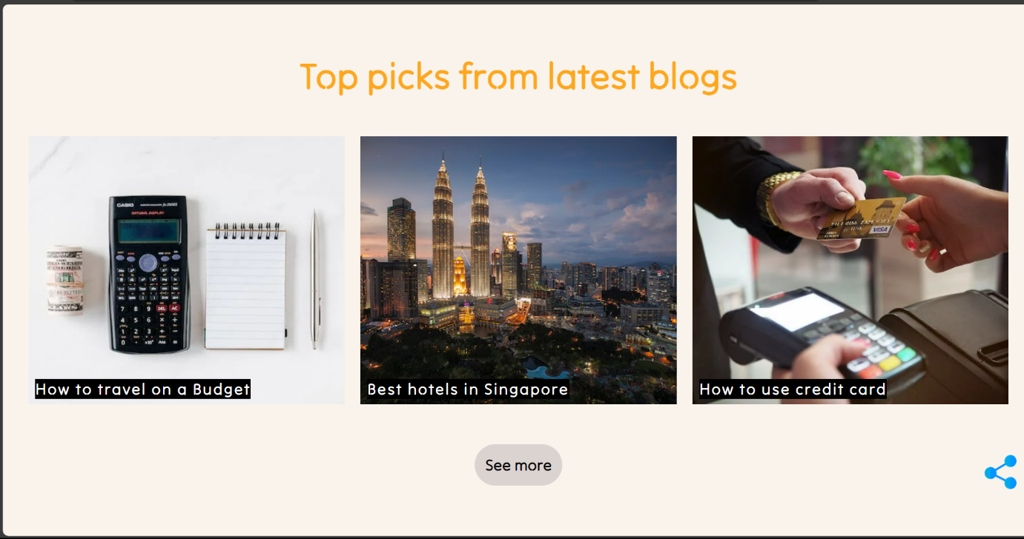Explore the world through our eyes with the latest blog posts from us.

Travel tips page

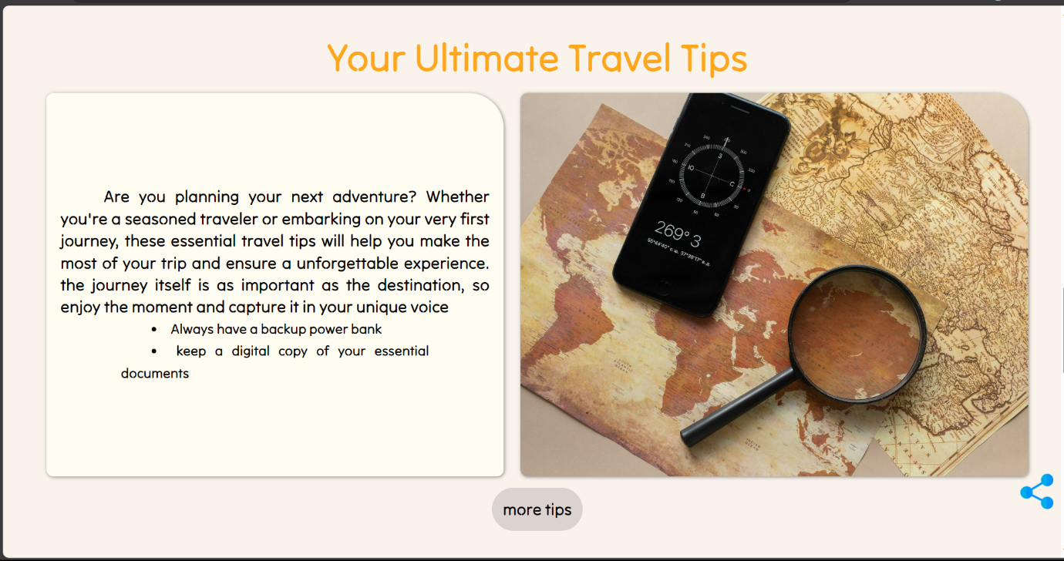Our tips page is your guide to travel wisdom, from packing hacks to cultural insights. Join us on a journey of discovery, empowerment, and the art of smart and enriching travel.

Destination page

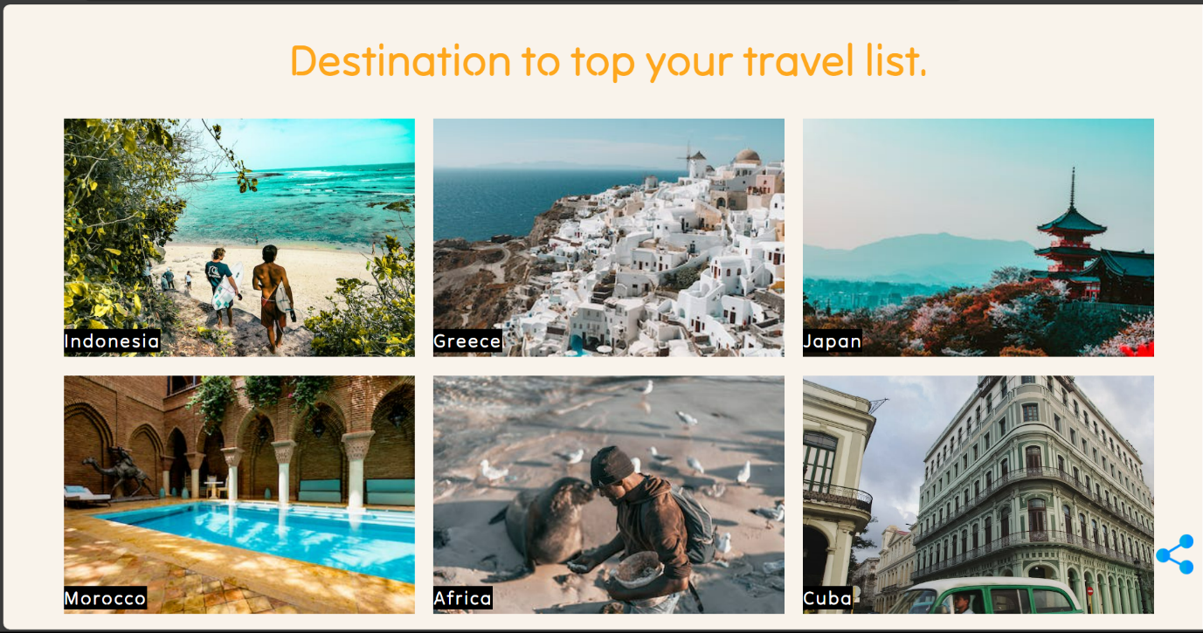Each destination is a unique chapter in your travel story, offering a kaleidoscope of experiences waiting to be explored.

Contact page

Your voice matters, and we're here to listen, respond, and engage with you. Whether you have questions, feedback, or simply want to reach out, drop us a message, and we'll get back to you as soon as possible.

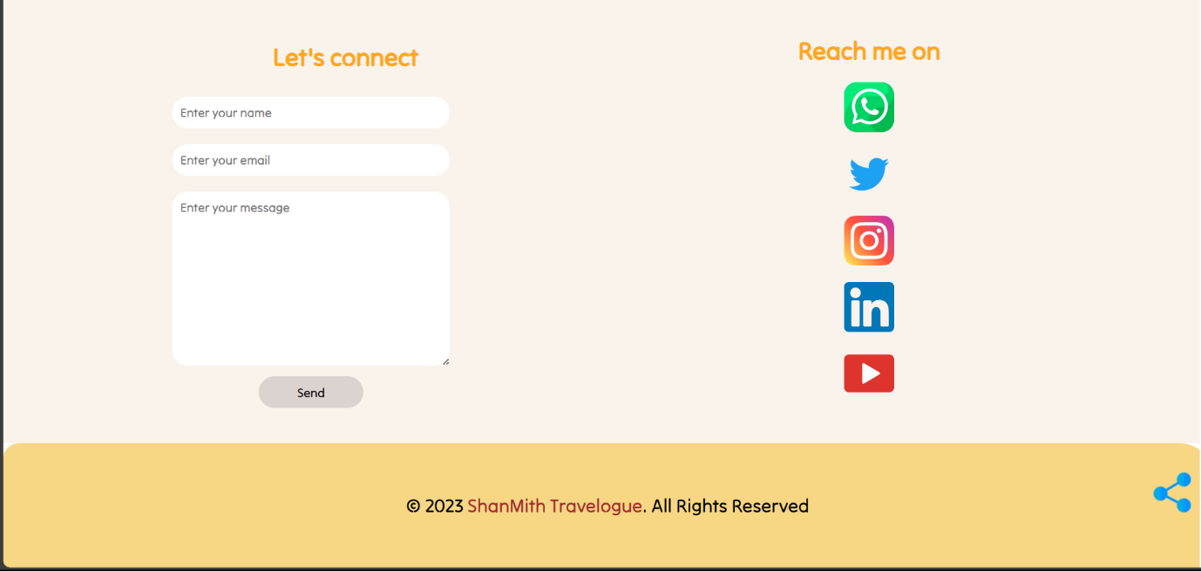

**Sample code:-**

HTML

<!DOCTYPE html>

<html lang="en">

<head>

    <meta charset="UTF-8">

    <meta name="viewport" content="width=device-width, initial-scale=1.0">

    <title>Travel blog</title>

    <link rel="stylesheet" type="text/css" href="{{ url_for('static', filename='css/style.css') }}">

</head>

<body>

    <!-- <h1>Welcome to the home page</h1> -->

    <!-- header starts -->

    <header id="home-sec">

        <!-- navbar starts -->

        <nav class="navbar">

            <img class="menu-btn" src="{{url_for('static',filename='images/menubtn.png')}}" alt="menu-btn">

            <div class="logo">

                <h1>ShanMith Travelogue </h1>

            </div>

            <ul class="links">

                <li><a href="#home-sec">HOME</a></li>

                <li><a href="#about-sec">ABOUT</a></li>

                <li><a href="#blog-sec">BLOG</a></li>

                <li><a href="#tips-sec">TRAVEL TIPS</a></li>

                <li><a href="#destination-sec">DESTINATIONS</a></li>

                <li><a href="#contact-sec">CONTACT</a></li>

            </ul>

        </nav>

        <!-- navbar ends -->

    </header>

CSS

header {

*font-size*: 2.5vmin;

*width*: 100vw;

*height*: 10vh;

}

.logo {

*display*: flex;

*justify-content*: start;

*align-items*: center;

*height*: 100%;

*width*: 30%;

*cursor*: pointer;

*color*: rgb(255, 255, 255);

*margin-left*: 2vmin;

}

Python-Flask

from flask import Flask,render_template

app = Flask(__name__)

@app.route('/')

@app.route('/home')

*def* hello_world():

    return render_template('index.html')

# Run the Flask app

if __name__ == '__main__':

    app.run(*debug*=True)

**Note:-** The above provided code is a sample for reference and demonstration purpose.

**Instructions on how to deploy the blog using IBM Cloud Static Web Apps.**

**Prerequisites**:

You should have an IBM Cloud account. If you don't have one, you can sign up at IBM Cloud Registration.

**Deployment** **Steps**:

**Log In to IBM Cloud:**

Visit IBM Cloud.

Log in to your IBM Cloud account using your credentials.

**Create a New IBM Cloud Static Web App:**

From the IBM Cloud dashboard, click on "Create Resource."

**Select Static Web App:**

In the "Resources" section, select "Static Web App."

Set Up the Static Web App:

Follow the prompts to set up your Static Web App.

You'll be guided through several steps:

*App Name:*

Choose a name for your web app.

*Source Repository:*

Connect your blog's GitHub repository to IBM Cloud by providing necessary permissions.

Specify the branch containing your blog's HTML content.

Define the folder in your repository where your content resides.

*Build Settings:*

Configure the build settings based on your chosen static site generator (e.g., Jekyll or Hugo).

Define the build command appropriate for your chosen generator (e.g., "jekyll build" for Jekyll).

**Create the Static Web App:**

After completing the setup, click the "Create" button.

IBM Cloud will now initiate the creation of your Static Web App.

**Deployment Process:**

IBM Cloud will handle the build and deployment process automatically.

Once the deployment process is complete, your travel blog will be live and accessible to the public.

**Access Your Deployed Blog:**

IBM Cloud will provide a link to your deployed blog. You can access it to ensure that everything is working as expected.rney, and a digital diary of my adventures around the world. With every story, photo, and tip I've shared, my goal has been not only to record my own travels but also to inspire and help fellow travelers in their exploration quests.

**Conclusion:-**

In conclusion, my personal travel blog has been a labor of love, a shared jouHere are instructions on how to deploy your travel blog using IBM Cloud Static Web Apps: